**Activity 0**

Noah Funderburgh

Grand Canyon University

Course Number: CST-323-O500

Jason Jazzar

11/12/2023

**node -v & npm -v**

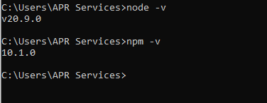

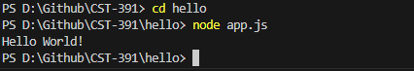**Hello World console app**

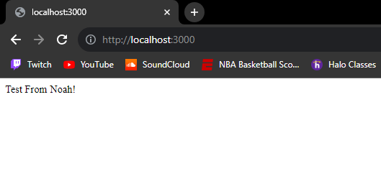**Hello World in browser**

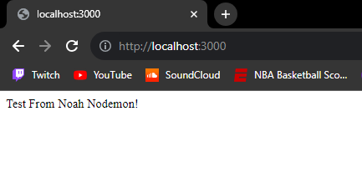**Hello World in browser with Nodemon**

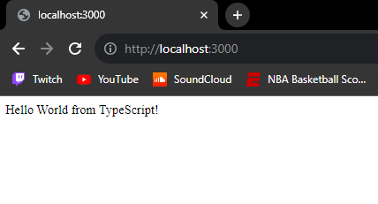**Hello World in browser with Typescript**

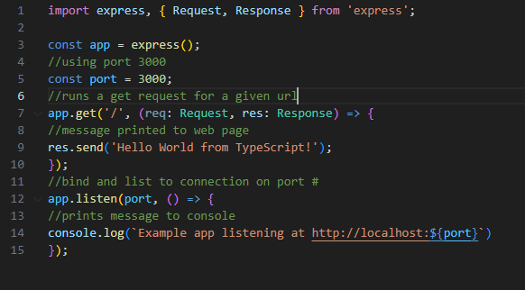**Commented app.ts**